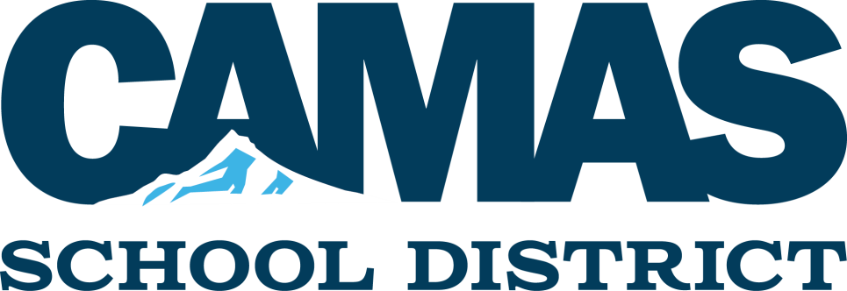
2017-18 Payday Calendar
Below is a list of the scheduled paydays for the 2017-18 school year.
Payday is the last business day of each month.
You can always view your pay information and pay history in the Employee Access portion of Skyward. Ifyou are new to the district, or you haven’t logged on to Employee Access, you can contact Vickie Gibson at extension 78238 for long-on information.
2017-18 Paydays:
September 29, 2017 March 30, 2018
October 31, 2017 April 30, 2018
November 30, 2017 May 31, 2018
December 29, 2017 June 29, 2018
January 31, 2018 July 31, 2018
February 28, 2018 August 31, 2018

Note: Timesheets are due in the payroll office by the 5th of each month for the previous month. (Example: September time sheets are due by October 5.) Late timesheets can result in a delay in your payroll processing!
The Talent Development Department (Human Resources & Payroll) is here to support staff and help with your employment needs. Please don’t hesitate to call us with questions!

Marilyn Boerke, Director of Talent Development, 78175
Jamie Stevenson, Certificated Payroll, 78226 Charlene Golder, Benefits, 78219
Maria Spencer, Classified/Cert Payroll (Sky, HBE, DFE, Sp. Serv.), 77272 Kris Cobleigh, Human Resources A-H, 78168
Leslie Rogers, Classified Payroll, 78119 (All Other Locations), 78119 Linda Artman, Human Resources I-Z, 78230

